**Types of Variables**

**Division 1 : Based on the type of value represented by a variable all variables are**

**divided into 2 types. They are:**

**1. Primitive variables**

**2. Reference variables**

Primitive variables:

**Primitive variables can be used to represent primitive values.**

Example: int x=10;

Reference variables:

Reference variables can be used to refer objects.

Example: Student s=new Student();

Diagram

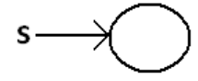

**Division 2 : Based on the behaviour and position of declaration all variables are divided**

**into the following 3 types.**

**1. Instance variables**

**2. Static variables**

**3. Local variables**

**Instance variables:**

• If the value of a variable is varied from object to object such type of variables are

called instance variables.

• For every object a separate copy of instance variables will be created.

• Instance variables will be created at the time of object creation and destroyed at

the time of object destruction hence the scope of instance variables is exactly

same as scope of objects.

• Instance variables will be stored on the heap as the part of object.

• Instance variables should be declared with in the class directly but outside of any

method or block or constructor.

• Instance variables can be accessed directly from Instance area. But cannot be

accessed directly from static area.

• But by using object reference we can access instance variables from static area.

**Example:**

class Test

{

int i=10;

public static void main(String[] args)

{

//System.out.println(i);

//C.E:non-static variable i cannot be referenced from a static

context(invalid)

Test t=new Test();

System.out.println(t.i);//10(valid)

t.methodOne();

}

public void methodOne()

{

System.out.println(i);//10(valid)

}

}

For the instance variables it is not required to perform initialization JVM will always

provide default values.

**Example:**

class Test

{

boolean b;

public static void main(String[] args)

{

Test t=new Test();

System.out.println(t.b);//false

}

}

**Instance variables also known as object level variables or attributes.**

**Static variables:**

• If the value of a variable is not varied from object to object such type of variables

is not recommended to declare as instance variables. We have to declare such

type of variables at class level by using static modifier.

• In the case of instance variables for every object a separate copy will be created

but in the case of static variables for entire class only one copy will be created

and shared by every object of that class.

• Static variables will be crated at the time of class loading and destroyed at the

time of class unloading hence the scope of the static variable is exactly same as

the scope of the .class file.

• Static variables will be stored in method area. Static variables should be declared

with in the class directly but outside of any method or block or constructor.

• Static variables can be accessed from both instance and static areas directly.

• We can access static variables either by class name or by object reference but

usage of class name is recommended.

• But within the same class it is not required to use class name we can access

directly.

**java TEST**

**1. Start JVM.**

**2. Create and start Main Thread by JVM.**

**3. Locate(find) Test.class by main Thread.**

**4. Load Test.class by main Thread. // static variable creation**

**5. Execution of main() method.**

**6. Unload Test.class // static variable destruction**

**7. Terminate main Thread.**

**8. Shutdown JVM.**

**Example:**

class Test

{static int i=10;

public static void main(String[] args)

{

Test t=new Test();

System.out.println(t.i);//10

System.out.println(Test.i);//10

System.out.println(i);//10

}

}

For the static variables it is not required to perform initialization explicitly, JVM will

always provide default values.

**Example:**

class Test

{

static String s;

public static void main(String[] args)

{

System.out.println(s);//null

}

**}**

**Example:**

class Test

{

int x=10;

static int y=20;

public static void main(String[] args)

{

Test t1=new Test();

t1.x=888;

t1.y=999;

Test t2=new Test();

System.out.println(t2.x+"----"+t2.y);//10----999

}

}

Diagram:

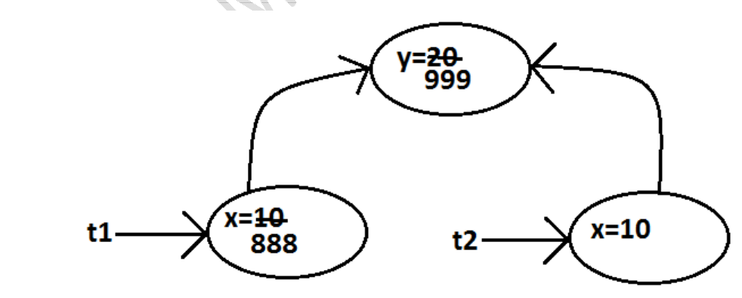

**Static variables also known as class level variables or fields.**

**Local variables:**

**Some times to meet temporary requirements of the programmer we can declare**

**variables inside a method or block or constructors such type of variables are called local**

**variables or automatic variables or temporary variables or stack variables.**

**Local variables will be stored inside stack.**

**The local variables will be created as part of the block execution in which it is declared**

**and destroyed once that block execution completes. Hence the scope of the local**

**variables is exactly same as scope of the block in which we declared.**

**Example 1:**

**class Test**

**{**

**public static void main(String[] args)**

**{**

**int i=0;**

**for(int j=0;j<3;j++)**

**{**

**i=i+j;**

**}**

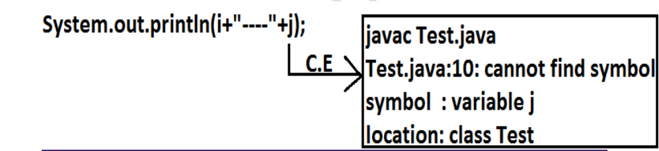

**• The local variables will be stored on the stack.**

**• For the local variables JVM won't provide any default values compulsory we**

**should perform initialization explicitly before using that variable.**

**• It is never recommended to perform initialization for the local variables inside**

**logical blocks because there is no guarantee of executing that block always at**

**runtime.**

**• It is highly recommended to perform initialization for the local variables at the**

**time of declaration at least with default values.**

**Note: The only applicable modifier for local variables is final. If we are using any other**

**modifier we will get compile time error.**

**Conclusions:**

**1. For the static and instance variables it is not required to perform initialization**

**explicitly JVM will provide default values. But for the local variables JVM won't**

**provide any default values compulsory we should perform initialization explicitly**

**before using that variable.**

**2. For every object a separate copy of instance variable will be created whereas for**

**entire class a single copy of static variable will be created. For every Thread a**

**separate copy of local variable will be created.**

**3. Instance and static variables can be accessed by multiple Threads simultaneously**

**and hence these are not Thread safe but local variables can be accessed by only**

**one Thread at a time and hence local variables are Thread safe.**

**4. If we are not declaring any modifier explicitly then it means default modifier but**

**this rule is applicable only for static and instance variables but not local variable.**